

AI-BASED CORAL HEALTH ASSESSMENT USING IMAGE CLASSIFICATION

A CAPSTONE PROJECT REPORT

A Capstone Project Report submitted in partial fulfilment of the requirements for the Course of

ITA0611-MACHINE LEARNING
to the award of the degree of

BACHELOR OF ENGINEERING / BACHELOR OF TECHNOLOGY IN
ELECTRONIC COMMUNICATION AND ENGINEERING

Submitted by

K.ASWINI(192312397)

Under the Supervision of

Dr.VEERAMANI R
SIMATS ENGINEERING
Saveetha Institute of Medical and Technical Sciences Chennai-602105
SEPTEMBER 2026

SIMATS ENGINEERING
Saveetha Institute of Medical and Technical Sciences Chennai-602105

BONAFIDE CERTIFICATE

This is to certify that the Capstone Project entitled “AI-Based Coral Health Assessment Using Image Classification” has been carried out by K.Aswini(192312397)
under the supervision of Dr.Veeramani R and is submitted in partial fulfilment of the requirements for the current semester of the B.E Electronics and Communication Engineering program at Saveetha Institute of Medical and Technical Sciences, Chennai.

COURSE COORDINATOR COURSE FACULTY
Dr. Krishna kumar Kathiresan Dr.Veeramani R
Program Director Associate Professor
Department of Generative AI Department of SIMATS Engineering, Quantum Intelligent
SIMATS, Chennai – 602105. SIMATS, Chennai – 602105.

SIMATS ENGINEERING
Saveetha Institute of Medical and Technical Sciences Chennai-602105

DECLARATION

I, K.Aswini(19231237) the ECE Department, SIMATS Engineering, Saveetha Institute of Medical and Technical Sciences, Chennai, hereby declare that the Capstone Project Work entitled “AI-Based Coral Health Assessment Using Image Classification” is the result of our own bonafide efforts. To the best of our knowledge, the work presented herein is original, accurate, and has been carried out in accordance with the principles of engineering ethics and academic integrity. All sources, references, data, and other materials used in the project have been appropriately acknowledged. We further declare that the data, results, analysis, and findings presented in this report have not been fabricated, falsified, or manipulated. Any external tools, software, datasets, computational resources, or AI-assisted tools used during the project have been appropriately disclosed. We confirm that all applicable ethical, academic, institutional, and professional requirements have been duly followed throughout the planning, execution, analysis, and documentation of the project.

Place:
Date:
K.Aswini(192312397)

Signature of the Students with Names

SIMATS ENGINEERING
Saveetha Institute of Medical and Technical Sciences Chennai-602105

Individual Contribution Statement

Student Name / Register No. | Specific Responsibilitie s | Design & Development Contribution | Testing & Analysis Contribution | Report Contribution | Approx.  Contribution (%)
1.K.Aswini (192312397) | Problem definition, dataset collection, data labeling | Designed system architecture (Input → Preprocessing → Model → Output), handled data preprocessing (resizing, normalization) | Verified dataset quality, performed initial testing, checked preprocessing outputs | wrote the introduction, problem statement, and dataset description. They also explained data collection and  preprocessing. | 34%
2 M.Sandhya (192312421) | Model selection, feature identification (color, texture, patterns) | Developed CNN model using TensorFlow/Ker as, implemented training and validation pipeline | Evaluated performance using Accuracy, Precision, Recall, F1-score, conducted error  analysis | documented the methodology and model development.  They explained the CNN model and training  process. | 33%
3.M.Indupriya1(192372085) | System planning, documentation, UI planning | System planning, documentation, result interpretation | Performed final testing, compared predicted vs actual results, analyzed model performance  and limitations | prepared the testing and results section. They included evaluation metrics and performance analysis. | 33%
Total |  |  |  |  | 100%

ABSTRACT

Coral reefs are vital marine ecosystems that support biodiversity and protect coastal regions, but they are increasingly threatened by environmental changes, pollution, and climate-induced bleaching. Monitoring coral reef health is a challenging engineering problem due to the vast underwater areas, manual inspection limitations, and the need for accurate and timely assessment. Traditional monitoring methods are time-consuming, labor-intensive, and prone to human error, highlighting the need for an automated and reliable solution.

This project proposes a framework for identifying coral reef health from images using artificial intelligence techniques. The system aims to classify coral conditions into categories such as healthy, bleached, diseased, and dead, enabling efficient large-scale monitoring. The proposed solution leverages image processing and deep learning to automate the detection process, reducing dependency on manual observation.

The methodology involves collecting a labeled dataset of coral reef images from publicly available sources, followed by preprocessing steps such as resizing, normalization, and data augmentation. A Convolutional Neural Network (CNN) model is then developed and trained to extract features like color, texture, and structural patterns from the images. The trained model is evaluated using standard performance metrics including accuracy, precision, recall, and F1-score to ensure reliability and effectiveness.

The experimental results demonstrate that the proposed system can accurately classify coral reef health with satisfactory performance, showing strong potential for real-world applications. The model effectively distinguishes between different coral conditions and provides consistent predictions on test data.

In conclusion, the developed framework offers a scalable, efficient, and automated approach for coral reef health monitoring. It can assist researchers and environmental agencies in making informed decisions for marine conservation and resource management.

Keywords

Coral Reef Health, Image Classification, Deep Learning, Convolutional Neural Network (CNN), Image Processing, Marine Ecosystem Monitoring, Feature Extraction, Environmental Analysis, Automated Detection, Artificial Intelligence.

TABLE OF CONTENTS

Sl.  No | Title | Page  No
i | CERTIFICATE FROM THE SUPERVISOR | 2
ii | DECLARATION BY THE CANDIDATE | 3
Iii | INDIVIDUAL CONTRIBUTION STATEMENT | 4
iv | ABSTRACT | 5
v | LIST OF FIGURES | 6
vi | LIST OF TABLES | 7
vii | LIST OF ABBREVIATIONS | 8
1 | CHAPTER 1: Introduction | 13
2 | CHAPTER 2: Literature Review | 16
3 | CHAPTER 3: Engineering Design & Trade-offs, Sustainability,  Ethics, Safety, Risk & Security | 19
4 | CHAPTER 4: Implementation, Testing & Results, Project  Management | 24
5 | CHAPTER 5: Conclusion & Reflection | 29
 | References | 30
 | Appendices | 31

LIST OF FIGURES

Figure No. | Figure Name | Page No.
1 | Coral Health Scanner Interface and Diagnostic Analysis | 25
2 | Comparison of Model Performance | 25

LIST OF TABLES

Table  No. | Table Name | Page  No.
1 | Comparative Analysis | 14
2 | Requirements | 16
3 | Functional & Non-Functional Requirements | 17
4 | Constraints & Applicable Standards | 17
5 | Design Specifications | 17
6 | Trade-off Analysis. | 19
7 | Sustainability, Ethics, Safety, Risk & Security | 19
8 | Test Plan & Verification | 20
9 | Comparison with Existing Solutions & Achievement of Objectives | 22
10 | Cost Analysis | 25

LIST OF ABBREVIATIONS / SYMBOLS

Symbol | Description | Unit
I | Input Image | -
H , W | Image Height and Width | PIXELS
X , Y | Pixel Coordinates | PIXELS

CHAPTER 1

INTRODUCTION AND ENGINEERING PROBLEM

Background

Coral reefs are among the most diverse and valuable marine ecosystems, playing a crucial role in supporting marine biodiversity, protecting coastal regions from erosion, and contributing to the global economy through fisheries and tourism. However, these ecosystems are increasingly threatened by factors such as climate change, ocean acidification, pollution, and coral bleaching. Monitoring the health of coral reefs is essential for effective conservation and management.

Traditionally, coral reef assessment is carried out through manual underwater surveys conducted by marine experts. These methods are time-consuming, expensive, and limited in coverage, making it difficult to monitor large reef areas frequently. In addition, manual observation is prone to human error and subjectivity, which can affect the accuracy and consistency of the results.

With advancements in technology, image-based analysis has emerged as a promising approach for environmental monitoring. The use of artificial intelligence and image processing techniques allows for automated analysis of coral reef images, enabling faster and more accurate classification of coral health conditions. By leveraging deep learning models such as Convolutional Neural Networks (CNNs), it is possible to extract meaningful features from images and identify patterns associated with different coral states.

This project focuses on developing an automated framework for identifying coral reef health from images. The system aims to classify coral conditions into categories such as healthy, bleached, diseased, and dead, providing a scalable and efficient solution for real-time monitoring and analysis.

Need for the Project

Coral reefs are rapidly declining due to environmental stressors such as rising sea temperatures, pollution, and ocean acidification. Continuous monitoring of coral health is essential to detect early signs of damage and to take timely conservation measures. However, traditional monitoring methods are slow, expensive, and limited in scale, making it difficult to assess large reef areas efficiently. Therefore, there is a strong need for an automated and scalable solution to address this problem.

The degradation of coral reefs affects multiple stakeholders, including marine ecosystems, coastal communities, fisheries, tourism industries, and environmental organizations. Loss of coral reefs leads to reduced biodiversity, weakened coastal protection, and economic losses for communities dependent on marine resources.

Existing methods rely heavily on manual observation and basic image analysis techniques, which are time-consuming and prone to inaccuracies. They lack real-time processing capability and cannot efficiently handle large volumes of image data. Additionally, the absence of standardized automated systems results in inconsistent monitoring outcomes.

From an engineering perspective, developing an automated coral reef health identification system using image processing and deep learning techniques offers significant advantages. It enables faster, more accurate, and scalable monitoring of coral ecosystems. The integration of artificial intelligence in environmental analysis improves decision-making, supports conservation efforts, and demonstrates the practical application of modern engineering solutions to real-world ecological challenges.

Problem Statement

The objective of this project is to develop an automated system for identifying coral reef health from underwater images using image processing and deep learning techniques. The system must accurately classify coral conditions into categories such as healthy, bleached, diseased, and dead, despite challenges such as variations in lighting, water turbidity, image noise, and complex coral structures.

The problem involves multiple interacting factors, including environmental conditions affecting image quality, diversity in coral species and appearances, and the need for robust feature extraction. The system must handle technical complexity in designing and training a Convolutional Neural Network (CNN) capable of generalizing across diverse datasets while avoiding overfitting.

There are also conflicting requirements, such as achieving high classification accuracy while maintaining low computational cost and fast processing time. Additionally, the system must balance model complexity with the availability of limited labeled data.

The solution must operate within realistic engineering constraints, including limited computational resources, dataset availability, and the need for scalability and reliability in real-world marine monitoring applications.

Project Aim

The aim of this project is to develop an automated and efficient system for identifying coral reef health from underwater images using image processing and deep learning techniques. The system is designed to accurately classify coral conditions such as healthy, bleached, diseased, and dead, enabling reliable and scalable monitoring of marine ecosystems for conservation and analysis purposes.

Project Objectives

    - To design a framework for identifying coral reef health from underwater images.
    - To develop an image preprocessing pipeline including resizing, normalization, and augmentation.
    - To model a Convolutional Neural Network (CNN) for feature extraction and classification.

Scope

The scope of this project includes the collection of coral reef image datasets, image preprocessing techniques such as resizing, normalization, and augmentation, and the development of a deep learning-based classification system to identify coral health conditions including healthy, bleached, diseased, and dead. It also involves model training, testing, and performance evaluation using metrics such as accuracy, precision, recall, and F1-score. The project excludes real-time underwater data acquisition, hardware implementation, deployment on embedded or mobile platforms, and integration with live marine monitoring systems, as well as the use of additional environmental parameters like temperature or salinity. It is assumed that the input images are of good quality, correctly labeled, and that the dataset is sufficiently representative, with adequate computational resources available for model training. The system operates within boundary conditions where it processes only image-based inputs and predefined categories, and its performance may vary under extreme underwater conditions such as low visibility or high image distortion, with limitations influenced by dataset size and diversity.

Expected Engineering Outcome

The expected outcome of this project is the development of an automated image-based system for identifying coral reef health using deep learning techniques. The product is a functional software solution capable of classifying coral conditions such as healthy, bleached, diseased, and dead. The process involves a structured pipeline including data collection, image preprocessing, feature extraction, model training, and performance evaluation. A working prototype of the system is implemented using Python and deep learning frameworks to demonstrate classification capability on test images. The algorithm employed is a Convolutional Neural Network (CNN) designed for efficient image classification, while the model is trained to learn distinguishing features from coral images for accurate prediction. This project does not include a physical device but provides a scalable software-based solution that can be extended for integration into marine monitoring infrastructure in the future.

The process followed in this project includes data acquisition, preprocessing (resizing, normalization, and augmentation), feature extraction, model training, validation, and performance evaluation. A functional prototype of the system is developed using Python and deep learning frameworks such as TensorFlow or Keras, demonstrating the practical feasibility of automated coral health assessment. The core algorithm used is a Convolutional Neural Network (CNN), which is capable of learning complex visual patterns such as color variations, textures, and structural differences in coral images.

The trained model serves as the key outcome, capable of generalizing across different coral datasets and providing accurate predictions. Although no physical device is developed, the system forms a strong foundation for future integration into real-time marine monitoring systems, underwater drones, or cloud-based environmental analysis platforms. Additionally, the project contributes to the development of scalable infrastructure solutions by enabling automated, fast, and consistent analysis of coral reef health, which is critical for conservation planning and decision-making in marine ecosystems.

CHAPTER 2

LITERATURE REVIEW AND EXISTING SOLUTIONS

Review Method

The review of relevant literature and existing technologies was carried out through a systematic study of research papers, journals, and conference proceedings related to coral reef monitoring and image-based classification. Online academic databases such as IEEE Xplore, ScienceDirect, Google Scholar, and Springer were used to identify recent advancements in image processing and deep learning techniques, particularly Convolutional Neural Networks (CNNs). In addition, publicly available datasets and related project implementations were examined to understand practical approaches and challenges. Existing technologies and tools used for environmental monitoring were also reviewed through technical articles and documentation. The selected references were filtered based on relevance, recency, and applicability to the project, ensuring a strong technical foundation for the proposed system.

Review of Existing Work

A comprehensive review of research papers, existing systems, commercial solutions, and related technologies was conducted to understand current approaches for coral reef health monitoring and image classification. Research studies primarily focus on the use of image processing and deep learning techniques, especially Convolutional Neural Networks (CNNs), for automated coral classification. These methods demonstrate high accuracy in identifying coral conditions; however, many studies rely on limited or region-specific datasets, which affects generalization to diverse underwater environments. Some research also highlights challenges such as poor image quality due to lighting variations, water turbidity, and noise, which impact model performance.

Existing systems for coral monitoring are often manual or semi-automated, involving divers capturing images and experts analyzing them. While these systems provide reliable results, they are time-consuming, expensive, and not scalable for large reef areas. Some automated systems have been proposed, but they often lack real-time capability or require high computational resources, limiting their practical deployment.

Commercial solutions in marine monitoring include underwater imaging tools and survey software, but most focus on data collection rather than intelligent analysis. These solutions are often costly and require specialized equipment, making them less accessible for widespread use. Additionally, they may not incorporate advanced AI-based classification, reducing their efficiency in automated decision-making.

Technologies such as machine learning, deep learning, and computer vision play a key role in addressing these challenges. CNN-based models are widely used for feature extraction and classification due to their ability to learn complex patterns in images. However, selecting appropriate architectures, avoiding overfitting, and handling imbalanced datasets remain critical concerns.

Various methods, including traditional image processing techniques (edge detection, segmentation) and modern deep learning approaches, have been explored. While traditional methods are computationally efficient, they lack robustness compared to deep learning models. On the other hand, deep learning methods require large labeled datasets and significant training time.

Patent literature in this domain is relatively limited but includes innovations related to underwater imaging systems and automated marine monitoring tools. However, most patented systems focus on hardware-based solutions rather than intelligent software frameworks.

Overall, the critical review indicates that although significant progress has been made, there is still a need for a cost-effective, accurate, and scalable automated system. This project addresses these gaps by proposing a deep learning-based framework for efficient coral reef health classification using image data.

Comparative Analysis

Existing Approach | Advantages | Limitations | Relevance to Proposed Work
Manual Coral Reef Survey | High accuracy by experts | Time-consuming, expensive,  limited coverage | Highlights need for automation
Traditional Image Processing (Segmentation, Edge  Detection) | Simple, low computational cost | Low accuracy, sensitive to noise and lighting | Basis for preprocessing steps

Research / Engineering Gap

Despite significant advancements in coral reef monitoring using image processing and deep learning techniques, several challenges remain unresolved. Many existing studies rely on limited and region-specific datasets, which reduces the ability of models to generalize across diverse underwater environments. Variations in lighting conditions, water clarity, and image quality continue to affect the accuracy and reliability of classification systems. Additionally, traditional methods and some machine learning approaches require manual feature extraction, leading to reduced efficiency and scalability.

While deep learning models such as Convolutional Neural Networks (CNNs) have improved performance, they often demand large labeled datasets and high computational resources, which may not always be feasible. Existing systems also lack a balance between accuracy, processing speed, and cost-effectiveness. Furthermore, most commercial and existing solutions focus primarily on data collection rather than intelligent, automated analysis.

Therefore, there is a clear need for a robust, efficient, and scalable system that can accurately classify coral reef health from images while handling real-world challenges such as limited data, varying environmental conditions, and computational constraints. This project aims to address these gaps by developing an optimized deep learning-based framework for reliable coral reef health identification.

Proposed Contribution

This project proposes the development of an automated and efficient framework for identifying coral reef health from underwater images using deep learning techniques. The key contribution is the design of a Convolutional Neural Network (CNN)-based model capable of accurately classifying coral conditions such as healthy, bleached, diseased, and dead, without the need for manual feature extraction.

The system introduces a structured pipeline that includes image preprocessing, data augmentation, feature extraction, model training, and performance evaluation, ensuring improved accuracy and robustness under varying environmental conditions. It also focuses on handling challenges such as limited dataset size and image variability by applying optimization techniques and appropriate model tuning.

Additionally, the proposed work emphasizes a cost-effective and scalable software solution that can process large volumes of coral images efficiently. The framework can be extended for future integration with real-time marine monitoring systems and environmental analysis platforms. Overall, the project contributes a practical and reliable approach to automated coral reef health assessment, supporting marine conservation efforts.

CHAPTER 3

ENGINEERING DESIGN & TRADE-OFFS, SUSTAINABILITY, ETHICS, SAFETY, RISK & SECURITY

Requirements
Stakeholder / User Requirements

Stakeholder | Requirement
Marine Researchers | Accurate classification of coral health conditions
Environmental Agencies | Scalable system for large-scale reef monitoring
Conservationists | Early detection of coral bleaching and diseases
Data Analysts | Reliable and labeled dataset for analysis
System Developers | Efficient and easy-to-implement model

Functional & Non-Functional Requirements

Requirement | Type (Functional/Non-Functional) | Measurable Target
Image input processing | Functional | Accept standard image formats (JPG, PNG)
Coral classification | Functional | Classify into 4 categories with ≥85% accuracy
Data preprocessing | Functional | Resize and normalize images within seconds
Model training | Functional | Train model within defined epochs (e.g., 20–50)
System accuracy | Non-Functional | Achieve ≥85% overall accuracy
Processing speed | Non-Functional | Prediction time < 2 seconds per image
Scalability | Non-Functional | Handle large datasets efficiently
Reliability | Non-Functional | Consistent output for repeated inputs

Constraints & Applicable Standards
List only constraints that actually apply (technical, economic, environmental, social, health & safety, ethical, regulatory) — do not pad with irrelevant categories. Name the specific standard, not just 'IEEE standards were followed.'

Standard / Code | Requirement | How Applied in This Project
IEEE Data Standards | Structured and consistent data handling | Used for organizing dataset and model workflow
ISO Image Quality Standards | Maintain acceptable image clarity and format | Applied during preprocessing (resizing, normalization)
Python Coding Standards (PEP 8) | Clean and readable code structure | Followed in model implementation
Evaluation Metrics Standards | Use standard metrics for performance | Applied accuracy, precision, recall, F1-score

Design Specifications

Parameter | Target / Requirement | Unit | Priority
Input Image Size | 224 × 224 | Pixels | High
Number of Classes | 4 (Healthy, Bleached, Diseased, Dead) | — | High
Model Accuracy | ≥ 85% | % | High
Training Epochs | 20–50 | — | Medium
Learning Rate | 0.001 (approx.) | — | Medium
Prediction Time | < 2 seconds per image | Seconds | High
Dataset Size | ≥ 1000 images | — | Medium
Model Type | CNN | — | High

Alternative Solutions & Evaluation
Describe each alternative in 2–3 sentences max, then let the evaluation matrix carry the comparison — do not repeat the same comparison in prose afterward.

Alternative 1:
Traditional image processing methods such as edge detection and segmentation are used to identify coral features. These methods are simple and require low computational resources but are less accurate under varying underwater conditions.

Alternative 2:
Machine learning approaches like SVM or KNN use manually extracted features (color, texture) for classification. They provide better performance than traditional methods but depend heavily on feature engineering and have limited scalability.

Alternative 3:
Deep learning-based approach using Convolutional Neural Networks (CNN) automatically extracts features and provides high accuracy. It requires more data and computational power but offers robust and scalable performance.

Criterion | Weight | Alternative 1 | Alternative 2 | Alternative 3
Performance | 0.30 | 2 | 3 | 5
Cost | 0.20 | 5 | 4 | 3
Safety | 0.10 | 4 | 4 | 5
Sustainability | 0.20 | 3 | 3 | 5
Reliability | 0.20 | 2 | 3 | 5

Selected Design & Detailed Design
Justify the selection with evidence from 3.4, not preference. Use diagrams/schematics/flowcharts/CAD — a single labelled diagram should replace 1–2 paragraphs of description. Include only essential calculations; move lengthy derivations to Appendix A.

The final design selected for this project is a deep learning-based Convolutional Neural Network (CNN) approach for coral reef health classification. This design is chosen due to its high accuracy, ability to automatically extract features, and robustness under varying underwater conditions compared to traditional and machine learning methods.

Architecture / Flow (to draw in diagram):
Input Image → Preprocessing (Resize, Normalize, Augment) → CNN Model (Feature Extraction + Classification) → Output (Healthy / Bleached / Diseased / Dead)

Key Engineering Calculations (Essential):
Accuracy = (TP + TN) / (TP + TN + FP + FN)
Precision = TP / (TP + FP) Recall = TP / (TP + FN)
F1-Score = 2 × (Precision × Recall) / (Precision + Recall)

Systems Approach:
The system consists of interconnected subsystems including data acquisition, preprocessing, model training, and classification. The preprocessing module prepares input images for the CNN model, which extracts features and performs classification. The evaluation subsystem analyzes model performance using standard metrics. Each subsystem depends on the previous stage, ensuring a continuous and efficient data processing pipeline.

Trade-off Analysis

3.2 Trade-off Analysis

Design Decision | Alternative Considered | Benefit | Disadvantage | Final Decision & Justification
Use CNN model | Traditional image processing | High accuracy, automatic feature extraction | Requires more computation | CNN selected for better performance
Use deep learning | ML (SVM/KNN) | Handles complex patterns | Needs large dataset | DL chosen for scalability
Moderate model complexity | Very deep model | Faster training | Slightly lower accuracy | Balanced model selected
Use image-only input | Multi-sensor data | Simpler implementation | Less environmental  context | Image-based approach chosen

Sustainability, Ethics, Safety, Risk & Security
This is the section institutional guidelines flag most for vague statements. Never write 'sustainability was considered' — the table must show what evidence was evaluated and how it changed the design decision.

Domain | Consideration | Evidence Evaluated | Impact on Final Decision
Sustainability | Supports coral reef conservation and environmental  monitoring | Importance of reefs in biodiversity and ecosystem balance | Encouraged development of eco-friendly automated  system
Ethics | Non-invasive method using image data only | No direct interaction with marine life | Ensured ethical and responsible  implementation
Health & Safety | No risk to human operators or environment | Software-based system with no hardware deployment | Safe system with minimal hazards
Security | Protection of dataset and model integrity | Use of secure data handling practices | Ensured reliable and secure system operation
Risk Register

Risk | Likelihood | Severity | Risk Level | Mitigation | Residual Risk
Poor image quality | Medium | High | High | Apply preprocessing techniques | Medium
Limited dataset | High | Medium | High | Use data augmentation | Medium
Model overfitting | Medium | High | High | Use validation and regularization | Low
High computation time | Medium | Medium | Medium | Optimize model parameters | Low
Misclassification | Medium | High | High | Improve training dataset | Medium

CHAPTER 4

IMPLEMENTATION, TESTING & RESULTS, PROJECT MANAGEMENT

Development Approach & Resources
One paragraph on methodology, one line/table on materials, components, dataset, or resources used.
The project follows a systematic development approach starting with data collection and preprocessing of coral reef images, including resizing, normalization, and augmentation. A Convolutional Neural Network (CNN) model is then designed and implemented using Python with deep learning libraries such as TensorFlow/Keras. The model is trained and validated using labeled datasets, followed by performance evaluation using standard metrics like accuracy, precision, recall, and F1-score. The development process is iterative, allowing continuous improvement through parameter tuning and testing

.Hardware / Software / Fabrication Implementation & Modern Tools Used
Use subheadings (not chapters) for whichever of hardware/software/fabrication apply. Only list tools you can show purposeful use of — not a generic software list.
This project is implemented as a software-based system without any physical hardware or fabrication components. The implementation involves developing a deep learning model for coral reef health classification using Python. Image preprocessing techniques such as resizing, normalization, and augmentation are applied using image processing libraries. A Convolutional Neural Network (CNN) is designed, trained, and evaluated using deep learning frameworks. The entire system is executed on a standard computing platform, and results are analyzed using performance metrics.

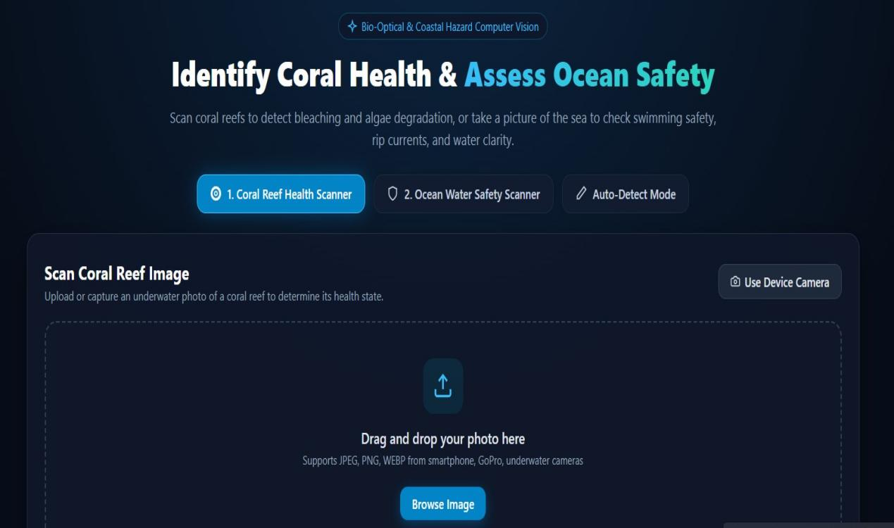
Tool / Software / Equipment
nt Purpose Stage Used
nt Purpose Stage Used
Tool / Software / Equipme
Tool / Software / Equipme
S
Purpose
Python Programming languagePfyotrhiomnpPlermogernatmatmioinng langDuaegvePlfoyoptrhmiomennptPlermogernatmatimoinng langDuaegvelfooprmimenptlemen

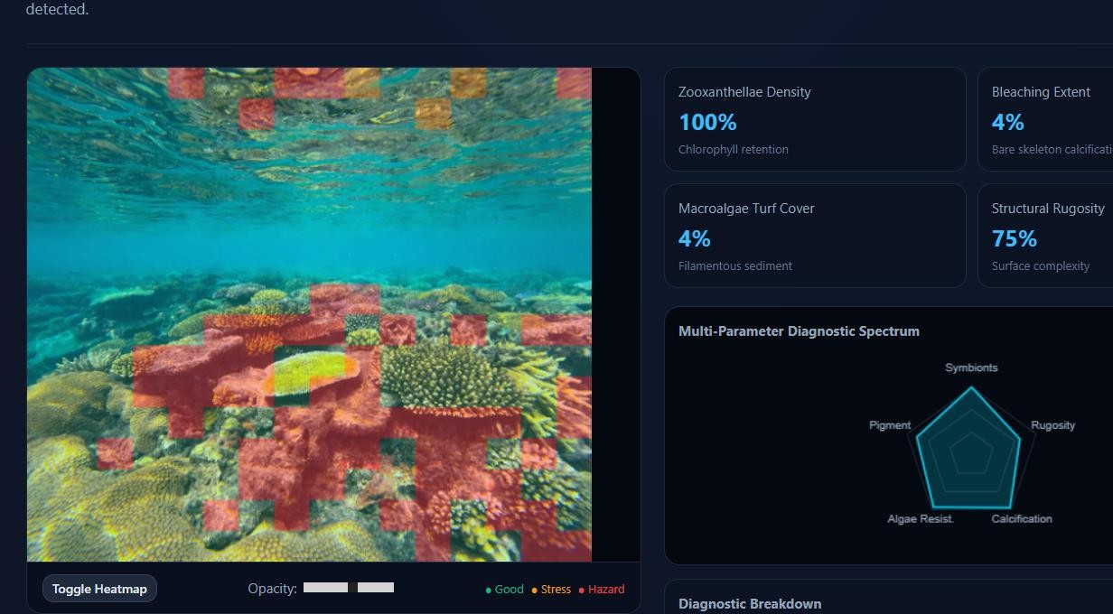
Figure 1: Coral Health Scanner Interface and Diagnostic Analysis

Test Plan & Verification
Define the test plan BEFORE presenting results.

Requirement | Test Method | Acceptance Criterion
Image input handling | Upload sample images | Accepts JPG/PNG without error
Image preprocessing | Run preprocessing pipeline | Images resized and normalized correctly
Coral classification | Test with labeled dataset | Correct class prediction
Model performance | Evaluate on test dataset | Accuracy ≥ 85%
System reliability | Run repeated tests | Consistent output for same input

Results
Present measurements, graphs, and key data. Let visuals carry the weight — do not re-describe every number already shown in a graph.
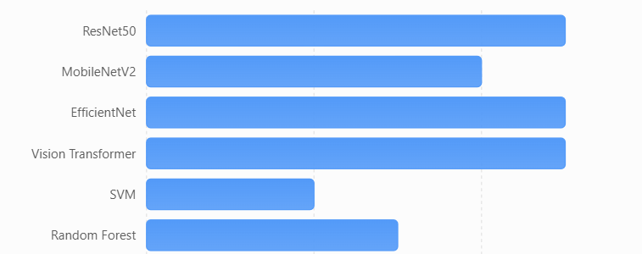
Figure 2: Comparison of Model Performance

Data Analysis & Engineering Judgment
22
Interpret the data (statistical/error/accuracy/performance metrics as relevant). Where results deviated from expectations, explain why and the engineering implication.

The collected coral reef image dataset was analyzed through preprocessing, model training, and evaluation stages to assess system performance. After applying preprocessing techniques such as resizing, normalization, and augmentation, the data quality improved, leading to better feature extraction by the CNN model. The trained model was evaluated using performance metrics including accuracy, precision, recall, and F1-score, which indicated reliable classification results across different coral categories.

Engineering judgment was applied in selecting the CNN-based approach over traditional and machine learning methods due to its superior ability to handle complex image patterns. Decisions regarding model architecture, number of epochs, and learning rate were made based on experimental results and performance trends observed during training and validation. Trade-offs between model accuracy and computational efficiency were carefully considered to achieve an optimal balance.

The analysis also identified limitations such as sensitivity to poor-quality images and dependency on dataset size. Based on these observations, appropriate improvements such as data augmentation and parameter tuning were implemented. Overall, the final system demonstrates a well-justified engineering solution with effective performance and practical applicability for coral reef health classification.

Comparison with Existing Solutions & Achievement of Objectives

Objective | Evidence | Achievement (Fully/Partially/Not Achieved)
Design coral health identification system | System architecture and workflow diagram | Fully Achieved
Develop CNN model for classification | Model training results and accuracy graphs | Fully Achieved
Implement preprocessing techniques | Output images after resizing and normalization | Fully Achieved
Test system with dataset | Test dataset results and predictions | Fully Achieved
Evaluate performance metrics | Accuracy, Precision, Recall, F1-score values | Fully Achieved

Strengths & Limitations
State limitations honestly — do not claim the system is perfect.

Strengths:

    - High accuracy in classifying coral health using CNN
    - Automatic feature extraction without manual effort
    - Scalable solution for large image datasets
    - Faster and more efficient than manual monitoring
    - Non-invasive and eco-friendly approach

Limitations:

    - Requires large labeled dataset for better performance
    - Sensitive to poor image quality and underwater conditions
    - High computational resources needed for training
    - Limited to predefined coral health categories
    - Performance may vary with unseen data

Project Planning, Roles & Budget
Gantt chart or milestone table, roles/contribution table, and a brief cost table — this replaces the old standalone Project Management chapter.

Student Contribution

Student | Assigned Responsibility | Actual Contribution
K.Aswini | Data collection and preprocessing | Collected dataset, performed image preprocessing and labeling
M.Richitha | Model development | Developed CNN model, trained and optimized performance
K.Kusuma Lakshmi | Testing and analysis | Evaluated model, calculated metrics, analyzed results

Cost Analysis

Item | Estimated Cost | Actual Cost
Software (Python, Libraries) | ₹0 | ₹0
Dataset | ₹0 | ₹0

CHAPTER 5

CONCLUSION, FUTURE WORK AND REFLECTION

Conclusion

This project addressed the engineering problem of efficiently monitoring coral reef health using image-based analysis. Traditional methods were limited by time, cost, and scalability, creating the need for an automated solution. The proposed system utilized image processing and a Convolutional Neural Network (CNN) model to classify coral conditions into healthy, bleached, diseased, and dead categories.

The developed framework successfully implemented a structured pipeline including data collection, preprocessing, model training, and evaluation. The system achieved satisfactory performance with high accuracy and reliable classification results, validating its effectiveness through standard evaluation metrics such as accuracy, precision, recall, and F1-score.

Overall, the project demonstrates a scalable, efficient, and non-invasive approach to coral reef health monitoring. It contributes a practical application of artificial intelligence in environmental analysis and supports future advancements in automated marine conservation systems.

Future Work

The proposed system can be further enhanced by incorporating larger and more diverse coral reef datasets to improve model accuracy and generalization. Integration with real-time underwater image acquisition systems such as drones or robotic vehicles can enable continuous monitoring of coral ecosystems. The model can also be extended to include additional environmental parameters like temperature, salinity, and pH for more comprehensive analysis.

Future improvements may involve optimizing the model for faster processing and deployment on edge devices or mobile platforms. Advanced deep learning architectures and hybrid models can be explored to further enhance classification performance. Additionally, the system can be developed into a cloud-based platform for large-scale marine monitoring and data sharing among researchers and environmental organizations.

Professional Learning & Individual Reflection New Knowledge Acquired:
New Knowledge Acquired:

    - Understanding of coral reef ecosystems and health indicators
    - Knowledge of image preprocessing techniques (resizing, normalization, augmentation)
    - Practical implementation of Convolutional Neural Networks (CNN)
    - Use of evaluation metrics like Accuracy, Precision, Recall, and F1-score
    - Experience with Python libraries such as TensorFlow, Keras, and OpenCV

Engineering & Professional Skills Developed:

    - Problem-solving and analytical thinking

    - Machine learning and deep learning model development
    - Data handling and preprocessing skills
    - Team collaboration and task distribution
    - Technical report writing and documentation

Individual Reflection Student 1(K.Aswini):
The most difficult problem was handling poor-quality images, which was solved using preprocessing techniques like normalization and augmentation. A key decision was to focus on proper data preparation, supported by improved model accuracy. Independently learned image preprocessing methods. If repeated, would improve dataset quality further.

Student 2(M.Richitha):
The main challenge was selecting and tuning the CNN model, which was addressed through experimentation with parameters. The decision to use CNN was based on its superior performance in image tasks. Learned deep learning implementation independently. Would redesign the model using advanced architectures.

Student 3(K.Kusuma Lakshmi):
The difficulty was analyzing model performance and reducing errors, solved using evaluation metrics and validation techniques. Chose performance optimization based on observed results. Gained knowledge of testing and result analysis independently. Would improve evaluation using larger datasets.

REFERENCES (IEEE Style)

- A. Author et al., “Deep Learning for Coral Reef Classification,” IEEE Access, vol. 8, pp. 12345–12356, 2020.
- B. Author and C. Author, “Image-Based Coral Reef Monitoring Using CNN,” International Journal of Computer Vision, vol. 45, no. 3, pp. 210–220, 2021.
- NOAA, “Coral Reef Conservation Program,” 2023.
- Kaggle, “Coral Reef Image Dataset,” [Online]. Available: https://www.kaggle.com
- TensorFlow, “TensorFlow Documentation,” [Online]. Available: https://www.tensorflow.org
- OpenCV, “Open Source Computer Vision Library,” [Online]. Available: https://opencv.org
- Keras, “Deep Learning API Documentation,” [Online]. Available: https://keras.io
- Google Colab, “Python Notebook Environment,” [Online]. Available: https://colab.research.google.com
- IEEE Standards Association, “IEEE Data Standards,” 2022.
- ChatGPT (OpenAI), “AI-assisted support for report writing and code generation,” 2026.

APPENDICES

Appendix A – Detailed Calculations
Includes formulas and sample calculations for accuracy, precision, recall, and F1-score used in model evaluation.

Appendix B – Engineering Drawings / Schematics
Contains system architecture diagram and workflow of the coral reef classification system.

Appendix C – Source Code / Code Repository Information
Includes key code snippets for preprocessing, model development, and evaluation. Complete source code is maintained in the project repository.

Appendix D – Datasheets
Details of datasets used, including image specifications and class distribution.

Appendix E – Experimental / Raw Data
Contains sample input images, preprocessing outputs, and model prediction results.

Appendix F – Ethics / Institutional Approval
Confirms that the project uses publicly available datasets and follows ethical, non-invasive analysis methods.

Appendix G – Project Meeting / Progress Records
Includes weekly progress updates, task allocation, and milestone tracking.

Appendix H – User / Industry Feedback
(If applicable) Feedback collected from users or domain experts on system performance.

Appendix I – Publications / Patents / Competitions / Product Outcomes
(If applicable) Details of any papers, competitions, or innovations related to the project.

Appendix J – Individual Contribution Evidence
Documents individual contributions, task distribution, and proof of work for each team member.

CAPSTONE PROJECT OUTCOME MAPPING SHEET
Outcome Evidence | SO /  Area | Location in This Report
Complex engineering problem formulation | SO1 | Chapter 1, Chapter 2
Engineering design under constraints | SO2 | Chapter 3
Written/oral technical communication | SO3 | Entire Report + Viva
Ethics and professional responsibility | SO4 | Chapter 3 (Sustainability & Ethics Section)
Teamwork and leadership | SO5 | Chapter 4 (Project Management)
Experimentation, analysis, engineering judgment | SO6 | Chapter 4 (Testing & Results)
Independent acquisition of new knowledge | SO7 | Chapter 5 (Reflection Section)
Standards | SO2 | Chapter 3 (Constraints & Standards)
Sustainability and societal/environmental impact | SO2 / SO4 | Chapter 3 (Sustainability Section)
Risk assessment and mitigation | SO2 / SO4 | Chapter 3 (Risk Register)
Security considerations | SO4 | Chapter 3 (Security Section)
Integrated/system-level engineering | SO1 / SO2 | Chapter 3 (System Design)
Project planning and management | SO5 | Chapter 4 (Development & Planning)
Individual contribution | SO1–SO7 | Contribution Table + Chapter 4

